* **Create project**
  + **Create Maven Project**
  + **Install library**

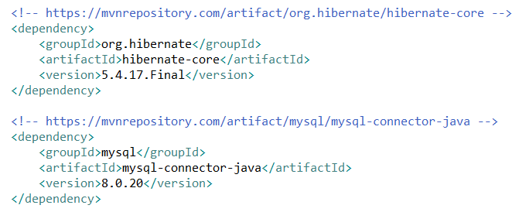

*<https://mvnrepository.com/artifact/org.hibernate/hibernate-core/5.4.17.Final>*

[*https://mvnrepository.com/artifact/mysql/mysql-connector-java/8.0.20*](https://mvnrepository.com/artifact/mysql/mysql-connector-java/8.0.20)

* + **Create the Configuration file**

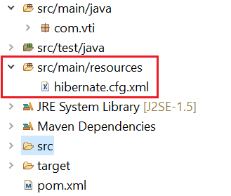 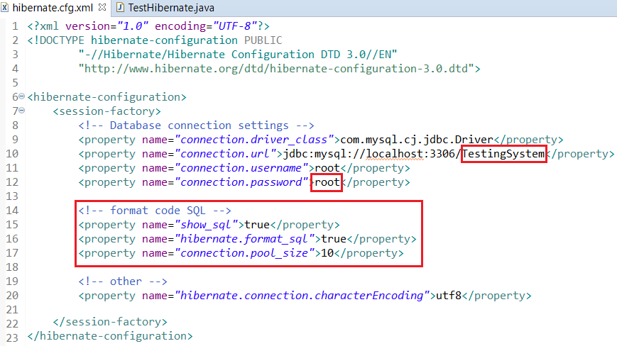

* + **Create Persistent Object**

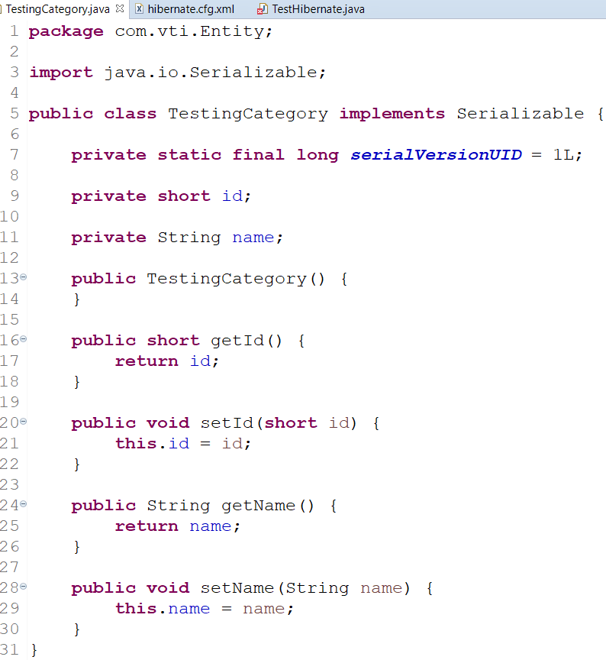

* + **Add the mapping for Persistent**

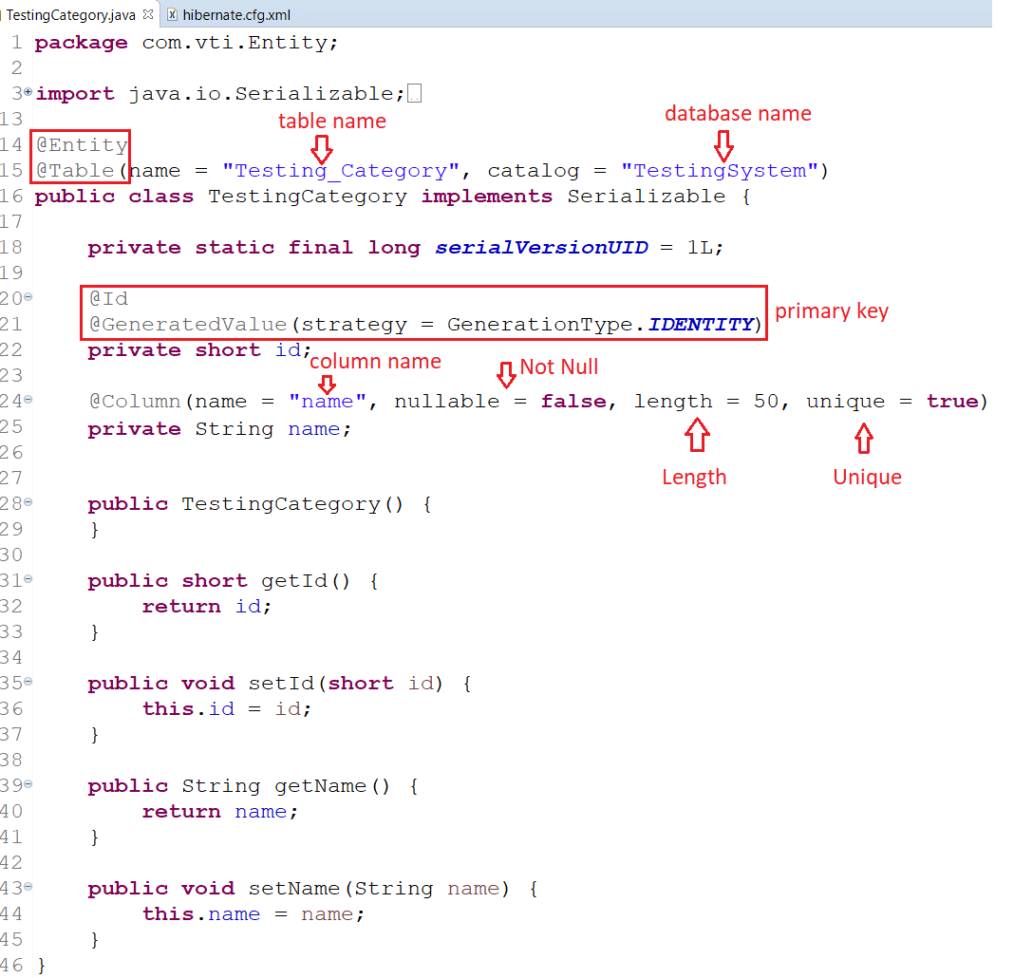

* + **Test CRUD**

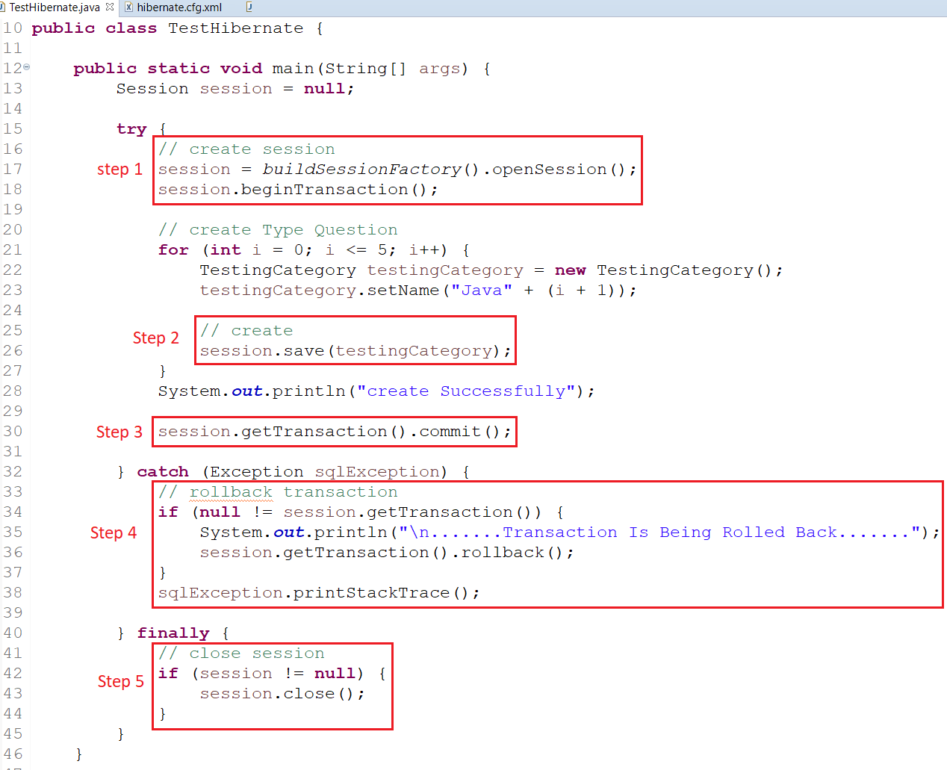

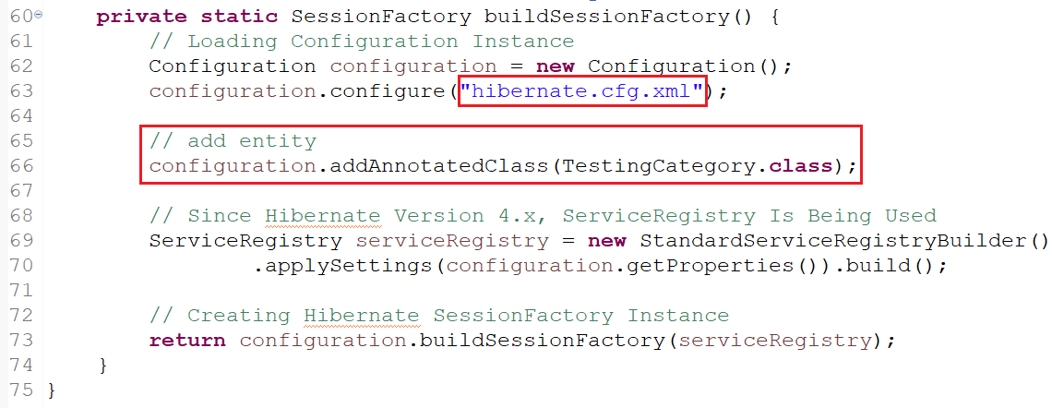

* + **Run Application**

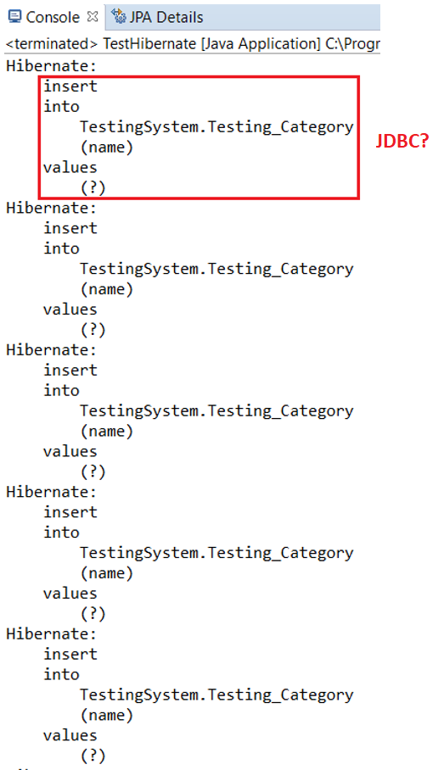

* **Reference**